**Experiment -3**

**AIM**: Write a program to demonstrate the working of the decision tree based ID3 algorithm. Use an appropriate data set for building the decision tree and apply this knowledge to classify a new sample.

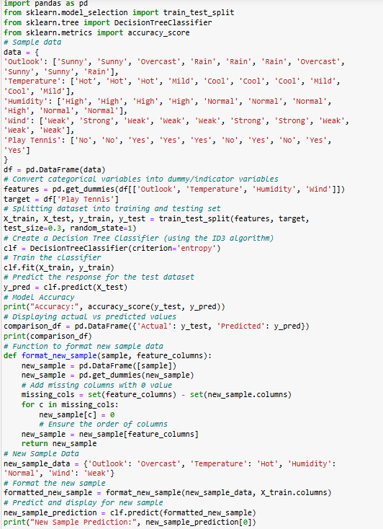

Open New Terminal in Jupyter notebook

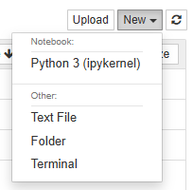

Install scikit-learn package:

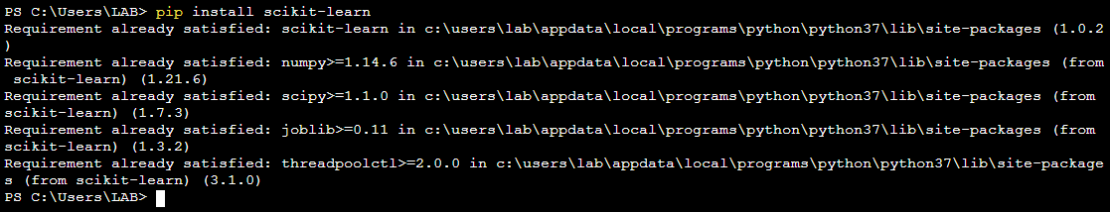**pip install scikit-learn**

**Output** :

